TestRail – Day 3: Sections & Hierarchical Test Organization
Date: 26-Jan-2026
Learning Objective
• To understand the concept of sections in TestRail
• To learn how to organize test cases hierarchically
• To create parent sections and sub-sections
• To improve test case structure and navigation
1. Sections in TestRail
Definition:
• A section in TestRail is a logical container used to group related test cases within a test suite.
Learning Points:
• Sections help organize test cases by feature or module
• Improve readability and navigation
• Make large test suites easier to manage

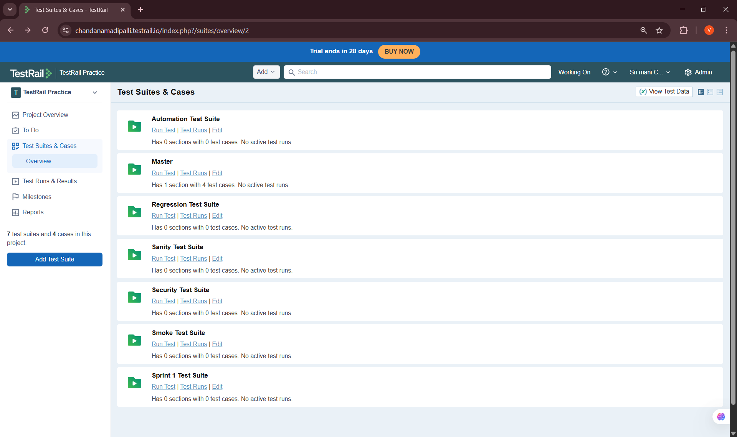
2. Hierarchical Organization of Test Cases
Definition:
• Hierarchical organization refers to structuring test cases using parent sections and sub-sections, similar to folders and subfolders.
Learning Points:
• Parent sections represent major modules
• Sub-sections represent sub-modules or features
• Reflects real application architecture

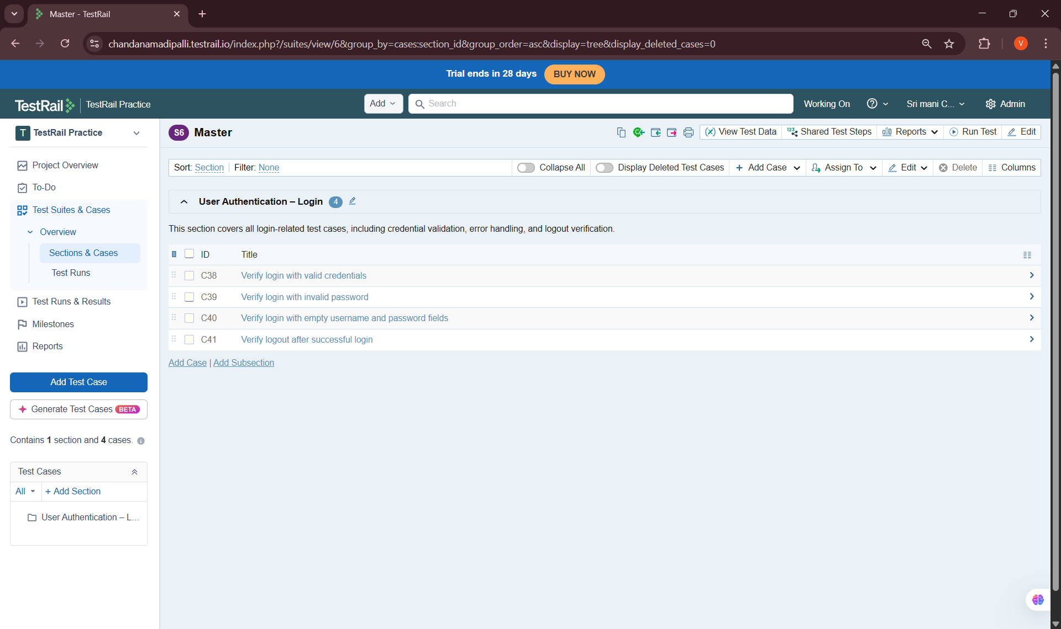
3. Parent Sections
Definition:
• A parent section is a top-level section that represents a major functional area of the application.
Learning Points:
• Created parent sections for major modules
• Used meaningful and professional naming
• Helped segregate test cases logically


4. Sub-Sections
Definition:
• A sub-section is a child section created under a parent section to further organize test cases.
Learning Points:
• Created sub-sections under parent sections
• Grouped related test cases together
• Improved clarity and structure


5. Adding Test Cases to Sections
Definition:
• Assigning test cases to sections ensures they are placed in the correct module hierarchy.
Learning Points:
• Added existing test cases to relevant sections
• Verified correct placement within hierarchy
• Ensured logical grouping

Key Learnings & Outcomes
• Understood the role of sections in TestRail
• Learned how to organize test cases hierarchically
• Gained hands-on experience creating parent and sub-sections
• Improved test case organization and navigation
• Built a scalable structure suitable for real projects

